**Case 5-Asia-China-Mirrors-Siberia-Yupik-Shamanism-Harding-1802**

**1802 Hand Watercolor Prints of a Siberian Yupik Inuit Shaman wearing a robe decorated with mirrors**

**E. Harding Pall Mall**





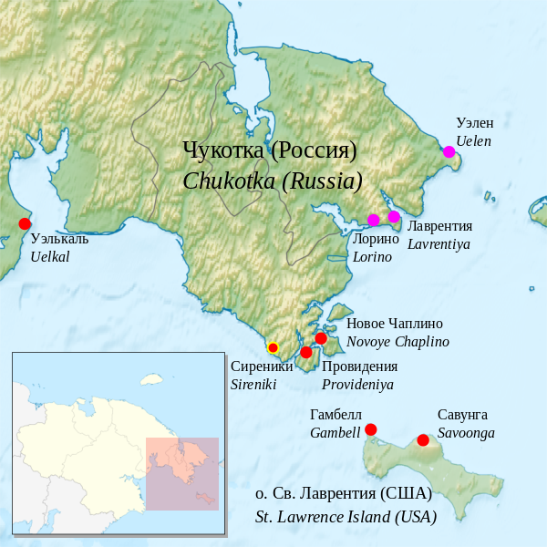

Yupik settlements in Chukotka and St. Lawrence Is. After Lyuboslov Ezykin. https://upload.wikimedia.org/wikipedia/commons/thumb/c/c8/Asian_Siberian_Yupik_Eskimo_map.svg/900px-Asian_Siberian_Yupik_Eskimo_map.svg.png

   Naukan dialect

   Chaplino – St. Lawrence dialect

   Sireniki dialect (*extinct*)